Joe O Flaherty T00155775



Lixnaw CCE

Website

Contents

Project Description 2

Scope Statement 3

Justification 3

Brief Description of Product 3

Deliverables – Customer 3

Deliverables – Project Team 4

Objectives 4

Time: 4

Cost: 4

Quality: 4

Assumptions 5

Constraints 5

Work Breakdown Structure (WBS) 5

Project Team 5

Level 1 6

Level 2 7

Level 3 8

Project Organization Chart 9

Gantt Chart 10

Project Budget 11

Summary Costs 11

Risk Analysis 12

Communications Plan 13

Meeting Plan 13

Reports 15

Contract Plan 16

Long term contract 16

Short term contract 17

Appendix 18

Gantt Chart 18

# Project Description

The Lixnaw branch of Comhaltas Ceoltoiri Eireann require the development of a website. The budget for the project is extremely limited (€1000 maximum), the project will be delivered by a team of volunteers.

Requirements specified as essential by the branch are:

* Theme that reflects the traditional cultural nature of the branch/organisation.
* Separate page for each category specified.
* Comprehensive history of the Lixnaw branch and Ceolann cultural centre as first/home page of the website.
* List of all classes that take place in the centre to include contact details for instructors and a timetable.
* Record number of visitors to the website.
* Ability to become a member of the branch via the website.
* Gallery page.
* News page.
* Social media follow options – Facebook, Twitter, and Google+.
* All pages easily updateable by **AUTHORIZED** users – Provide secure log-in options.
* Events page – used to inform members on details of upcoming competitions.
* Sales/Exchange section – allows members to sell or search for 2nd hand instruments, dancing costumes, dancing shoes.
* Link to Comhaltas Ceoltoiri Eireann website.
* Advertise the ‘new’ website using social media and local news providers (Parish newsletter, Community notes in local newspapers, local radio).

The bulk of the budget will be used to host the website unless a cheaper alternative can be provided by the developer. The branch has requested a prototype of the initial design particularly colour scheme be provided for approval before full development commences. The time limit specified for development by the branch is 3 months from the initial approval of the first requested prototype.

# Scope Statement

## Justification

* To promote the ethos and history of Lixnaw CCE.
* To increase awareness and provide details of the classes and activities the branch provides.
* To provide an easily accessible source of information to members.
* To offer a means of recognising the achievements of members of the branch.
* To attract new members and provide prospective members a straight-forward online membership form.
* To increase the social media presence and interactions of the branch.

## Brief Description of Product

* Development of a website for Lixnaw CCE that meets the criteria specified by the branch. The website will include multiple pages broken down by content and function. Administration of the finished site will be accessible and straight-forward for administrators and user(s). The cost of hosting the site will be kept to an absolute minimum.

## Deliverables – Customer

* Initial design prototype displaying theme and colour scheme for approval.
* Paper based design of entire website.
* Basic prototype of each page prior to development.
* Final demo of complete site prior to launch.
* Suitable publicity/advertising of the website.
* Launch night for the website.
* Comprehensive instructional document to enable ease of use by approved users’ i.e. adding or changing content/information.
* Log-in details for hosting provider.
* Training provided in site management.
* Automated report of visitor statistics.

## Deliverables – Project Team

* Initial design prototype displaying theme and colour scheme for approval.
* Skeleton of each page with functioning navigation links. Also serves as a prototype for the branch.
* All pages include Social Media links in page footer.
* Home Page.
* Class information page.
* News Page.
* Gallery Page.
* Events Page.
* Sales/Exchange Page.
* New Member/ Contact Page.
* Marketing/promotional strategy.
* Marketing/Promotion campaign
* Final demo of complete site prior to launch.
* Hosting provider identified and account created.
* Launch night for the website.

## Objectives

### Time:

* Project completed no later than 3 months from the date project design begins.

### Cost:

* Total cost of the project including hosting of the website must not exceed €1000.
* Costs should be minimised wherever possible.

### Quality:

* Professional standard design.
* Fully user tested.
* Ease of and logical navigation for site visitors.
* All links and forms tested and working.
* Ongoing site management is straightforward.
* Finished site passes branch acceptance test.

# Assumptions

* That enough volunteers with the correct skill-set will be available over the lifetime of the project.
* That volunteers have access to suitable equipment – Hardware/Software.
* That the limited budget will be adequate for completion of the project.
* That there are branch members capable of managing the website.

# Constraints

* Budget limited to €1000
* Child Protection Legislation – No children can be specifically identified in photographs without express parental permission.
* Voluntary development team with limited available time to work on the project.
* Approval of the initial design prototype.
* Approval from CCE Ireland. – The site must reflect the ethos of CCE.

# Work Breakdown Structure (WBS)

## Project Team

* Joe O Flaherty – Project Manager/Designer/Developer.
* John Griffin – Designer/Developer.
* Cathy O Sullivan – Marketing/Communications/Training.
* Bridie Stack – Marketing/User Testing.
* Liz O Keeffe – Research/Marketing (Launch).
* Mike Kissane – Developer/Tester.
* John McCarthy – Student Web Developer.
* John Brophy – User Testing.
* Sandra Lynch – Marketing Student.
* Maura Walsh – Part-time research assistant.

**Note:** Both students are gaining experience as part of a work placement module.

## Level 1

## Level 2

## Level 3

Limited level 3 WBS included to show individual web page development.

# Project Organization Chart

Note:

Lixnaw CCE committee, the members of Lixnaw CCE and the wider Lixnaw community are included on the P.O.C as they are each a stakeholder in this project.

# Gantt Chart

Complete project Gantt chart is available in attached appendix.

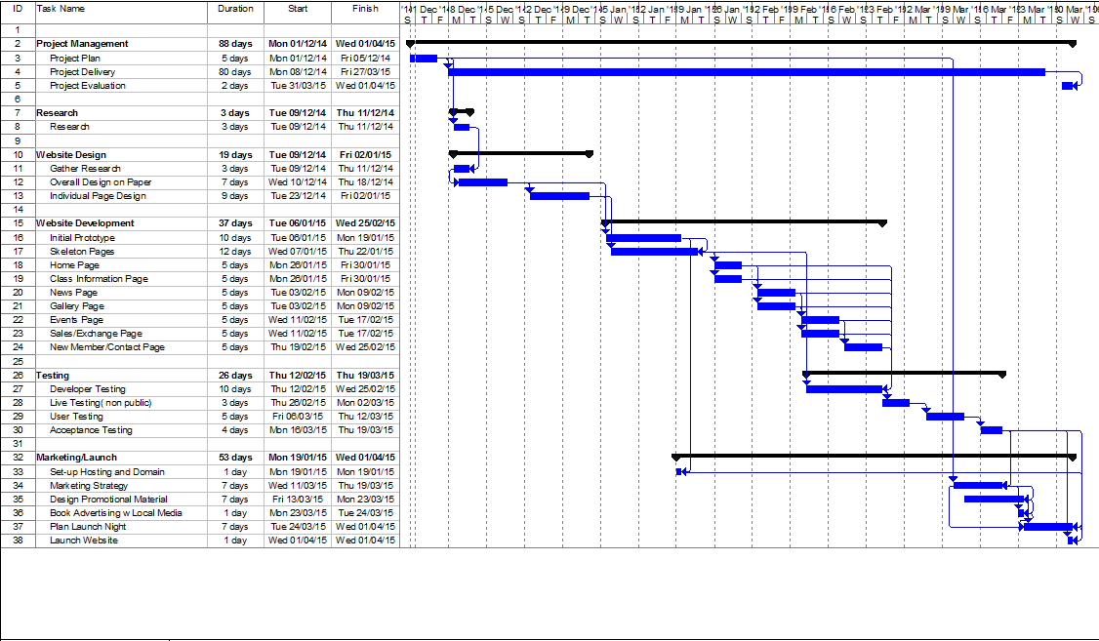

# Project Budget

Total project budget is €1000 and is the maximum amount available to cover all costs related to the project. The main expenses foreseen are advertising and launch of the website plus the cost of website hosting and domain name acquisition.

## Summary Costs

|  |  |  |  |  |
| --- | --- | --- | --- | --- |
| **Task Name** | **Labour** | **Materials/Sundries** | **Subcontract** | **Total** |
| Project Management | 00.00 | 50.00 | 00.00 | 50.00 |
| Research | 00.00 | 35.00 | 00.00 | 35.00 |
| Website Design | 00.00 | 50.00 | 00.00 | 50.00 |
| Website Development | 00.00 | 00.00 | 00.00 | 00.00 |
| Website Testing | 00.00 | 00.00 | 00.00 | 00.00 |
| Marketing/Launch | 00.00 | 435.00 | 120.00 | 485.00 |
| Website Hosting | 00.00 | 00.00 | 199.95 | 199.95 |
| Training | 00.00 | 100.00 | 00.00 | 100.00 |
| **TOTALS** | **00.00** | **670.00** | **319.95** | **989.95** |

Note: All amounts are in Euro (€).

Note: Website hosting includes the domain name [www.lixnawcce.ie](http://www.lixnawcce.ie) and 10 years hosting. Services are provided by HostingIreland.ie, the contract was secured as part of a special promotion by the company (refer to Contract Plan).

# Risk Analysis

|  |  |  |  |  |  |  |  |  |  |  |  |
| --- | --- | --- | --- | --- | --- | --- | --- | --- | --- | --- | --- |
| **RISK SOURCE** | **Probability** | | | **Impact** | | | **Result** | **Impact Area** | | | **Comments** |
| **Low** | **Medium** | **High** | **Low** | **Medium** | **High** | **Prob * Impact** | **Cost** | **Sched** | **Perf** |
| 1 - 3 | 4 -7 | 8 - 10 | 1 - 3 | 4 -7 | 8 - 10 |  |  | | |
| Non approval of prototype |  | 5 |  |  |  | 10 | 50 |  | X | X | High impact on the project as it prevents progress until approval is received |
| Rejection by Comhaltas Ceoltoiri Eireann | 1 |  |  |  |  | 10 | 10 |  | X | X | Very unlikely as the initial prototype approved by the branch will fit the ethos of CCE. |
| Withdrawal of support from Lixnaw CCE | 1 |  |  |  |  | 10 |  |  | X | X | Project is terminated. |
| Unavailable staff |  |  | 8 |  |  | 8 | 64 |  | X | X | Staff on the project are voluntary with a high likelihood of time constraints on individuals.  Recruit extra volunteers.  Tasks are divided to mitigate against this. |
| Resistance from Committee | 2 |  |  |  |  | 9 | 18 |  | X |  | Unlikely but comes with a high impact to project progress. |
| Disapproval from members/community | 1 |  |  |  |  | 8 | 8 |  | X |  | Very unlikely, serious impact if disapproval arises. |
| Project over budget | 1 |  |  |  |  | 10 | 8 | X |  |  | Unlikely as costs associated with the project are minimal. Costs will be reduced initially in advertising budget in the event of possible overrun.  Request additional funding if project completion is threatened. |
| Project over schedule |  | 5 |  |  |  | 9 | 45 | X | X | X | Medium likelihood with high impact, lag built into project plan to mitigate against this possibility. |
| Non Compliance with Child Welfare Legislation. | 1 |  |  |  |  | 10 | 20 |  | X | X | Lixnaw CCE will host a mandatory Child Protection training course for all relevant parties prior to project commencement. |

# Communications Plan

## Meeting Plan

|  |  |  |  |
| --- | --- | --- | --- |
| **Meeting Type** | **Scope Outline** | **Attendance** | **Frequency** |
|  |  |  |  |
| Project Start Meeting. | Define the scope of the project, identify issues and impacts. | Project Manager, Chairperson and Secretary of Lixnaw CCE. | Once prior to official start of the project. |
| Key Stakeholders. | Outline scope of the project, define items for inclusion/exclusion. | Project Manager, Committee of Lixnaw CCE, Project team, Members of Lixnaw CCE. | Once to agree final project scope and content. |
| Approval Meeting. | Confirm approval from Lixnaw CCE and CCE Eireann. | Project Manager, Chairperson of Lixnaw CCE, Secretary of Lixnaw CCE | Once to confirm approval of design and content. |
| Progress Monitoring. | Report on progress, outline and discuss any issues. | Project Manager, Chairperson and Secretary of Lixnaw CCE. | Fortnightly. |
| Progress Meeting. | Report on progress, outline and discuss any issues. | Project Manager, Project team. | Weekly. |
| Progress Meeting. | Report on progress being achieved, highlight any issues. | Project Manager, Committee of Lixnaw CCE, Project team. | Monthly. |
| Marketing Meeting. | Discuss advertising campaign, promotional strategy, review promotional materials. | Project Manager, Chairperson Lixnaw CCE, Cathy O Sullivan, Bridie Stack. | 1st meeting one month into project lifecycle, fortnightly thereafter. |
| Launch Night Meeting. | Discuss details of website launch night. | Project Manager, Chairperson Lixnaw CCE, Cathy O Sullivan, Bridie Stack, Lixnaw CCE committee members | First meeting 1 month prior to scheduled completion, weekly thereafter. |
| User Training Plan Meeting. | Discuss user training plan and user training document content. | Project Manager, Cathy O Sullivan | Once. |
| User Training Progress Meeting. | Discuss progress on user training manual design. Discuss schedule and delivery of user training. | Project Manager, Cathy O Sullivan, Chairperson of Lixnaw CCE. | Weekly. |
| Financial Review Meeting. | Discuss budget details, expenditure to date and projected costs. | Project Manager, Chairperson and Treasurer Lixnaw CCE | Fortnightly. |
| Project Review Meeting. | Discuss completed project, outline any issues, and receive feedback. | Project Manager, Committee of Lixnaw CCE, Project team, members of Lixnaw CCE. | Twice:  One week prior to official launch.  One week following the official launch. |
| Project Post-Mortem. | Discuss completed project, review process, what went right, what went wrong, close project. | Project Manager, Project team, Chairperson Lixnaw CCE, Secretary Lixnaw CCE. | Once 1 week following project launch. |
| Work placement meeting. | Meet with work placement students. Discuss their experiences, what they have gained and what feedback they have. | Project Manager, John Griffin, Cathy O Sullivan, Sandra Lynch, John McCarthy. | Once following launch of the website. |

## Reports

|  |  |  |  |
| --- | --- | --- | --- |
| **Report Name** | **Contents** | **Distribution** | **Frequency** |
| Project Overview | Overview of the proposed project. Includes description and images of approved prototype. Details of project team, roles and responsibilities. | Project team, Committee of LixnawCCE. | Once following approval of initial prototype has been received. |
| Progress Report | Progress of project to date. Details of any impediments. Includes images of completed features. | Project team, Committee of  LixnawCCE. | Fortnightly, keeping to schedule of Progress Monitoring meetings. |
| Financial Report | Details of expenditure to date. Contracts overview and costs associated. | Project Team, Committee of LixnawCCE. | Monthly. |
| Marketing/Advertising Report | Details of marketing and advertising plan. Includes samples of advertising materials where available. | Project Team, Committee of LixnawCCE. | Monthly. |
| Training Report. | Report on training plan and delivery of user training. | Project Team, Committee of LixnawCCE, relevant users/administrators. | Twice:  Once on completion of user training manual.  Once on completion of user training. |
| Project Launch Report | Report on plans and details of project launch night | Project Team, Committee of LixnawCCE. | Once one week prior to project launch night. |
| Project Completion Report | Post-mortem report on the completed project. Highlighting successes, difficulties and budget breakdown. | Project Team, Committee of LixnawCCE, LixnawCCE adult members. | Once on project completion. |
| Student Work Placement Report | Report to work placement student’s academic supervisor, detailing student performance and achievements. | Work placement academic supervisor | Once. Submission deadline specified by the academic |

# Contract Plan

## Long term contract

|  |  |  |  |  |  |  |  |
| --- | --- | --- | --- | --- | --- | --- | --- |
| **Vendors** |  | **HostingIreland.ie** | | **Register365.com** | | **LetsHost.ie** | |
| **Criteria** | **Weight** | **Rating** | **Score** | **Rating** | **Score** | **Rating** | **Score** |
| Technical Approach | 30% | 2 | 27% | 1 | 30% | 3 | 16% |
| Management Approach | 20% | 1 | 20% | 3 | 11% | 2 | 17% |
| Past Performance | 20% | 1 | 20% | 2 | 18% | 3 | 12% |
| Price | 30% | 1 | 30% | 3 | 14% | 2 | 22% |
| Total Score | 100% |  | 97% |  | 73% |  | 67% |

Resulting from a comparison of 3 providers HostingIreland.ie is identified as the most suitable option, a special promotional offer provides 10 years web hosting plus a domain name costing €199.95.

The contract with the vendor is a fixed price contract that also contains a unit price clause for usage exceeding a specified limit. Termination of the contract by the buyer is based on the specified service not being delivered as per contract agreement, the seller may terminate the contract due to improper usage and/or failure to pay for services provided.

## Short term contract

A requirement by the project owner is that the website is suitably advertised. Meeting this requires a series of adverts on a local radio station.

Radio Kerry being the only option is selected by default.

Radio Kerry provide small adverts for a non-negotiable fixed price of €30 per day. The marketing strategy developed by the project team requires these adverts to run on 4 consecutive days leading up to the launch of the website.

**Total cost of contract with Radio Kerry €120.00.**

# Appendix

## Gantt Chart

Summary and detailed Gantt charts are attached overleaf.